# Purpose

The purpose of this form is to define a set of courses (hereinafter referred to as the "Program of Study" or "PoS") in lieu of a set of core and elective courses that shall constitute a Master of Science (M.S.) or Doctor of Philosophy (Ph.D.) degree in Civil or Architectural Engineering. Each student's "Program of Study" defines the course requirements for graduation and must be approved by a supervisory committee.

For M.S. students, the Program of Study must be fully approved prior to registration for graduate courses.

For Ph.D. students, only the Program of Study Acknowledgement & Agreement must be signed prior to registration for graduate courses. The remaining sections of the Program of Study must be fully approved prior to admission to Ph.D. candidacy.

Every student has the responsibility to complete this form and obtain written concurrence from the members of his/her supervisory committee.

# Supervisory Committee Requirements

The membership requirements for each student's supervisory committee is summarized below. A separate dissertation committee may be formed to oversee the progress of the dissertation (if applicable) but, in most instances, the student's supervisory committee also serves as the dissertation committee. Refer to the online [Graduate Faculty List](http://grad.miami.edu/graduate-education/graduate-faculty/index.html).

|  |
| --- |
| Master's (MS): Minimum of 3 members:   1. Committee Chair (Advisor) shall be full-time CAE faculty and a member of the Graduate Faculty. 2. Full-time or part-time CAE faculty. 3. Non-CAE (external) member with an earned Ph.D.   ☝ In addition to the Committee Chair, at least one member must be tenured/tenure-earning or Graduate Faculty. |
| Doctoral (Ph.D.): Minimum of 4 members:   1. Committee Chair (Advisor) shall be full-time CAE faculty and a member of the Graduate Faculty. 2. CAE faculty and a member of the Graduate Faculty. 3. CAE faculty and a member of the Graduate Faculty. 4. Non-CAE (external) member with an earned Ph.D. |

# Course Requirements

## Groups

Courses have been classified into one of eight "Groups" as summarized in the table on the following page. The complete list of courses and their corresponding Groups can be found in the [Academic Bulletin](http://bulletin.miami.edu/courses-az/cae/) and in the "CAE Course Groups and Rotation" document posted on the [CAE Graduate Program](https://cae.coe.miami.edu/graduate/index.html) website under Graduate Student Resources.

The following abbreviations are often used: AEN and CEN. They refer to the two major fields within the CAE Department, namely, architectural engineering (AEN) and civil engineering (CEN). The abbreviation ENE is used to indicate courses in environmental engineering, which are offered by the CET department.



Students are required to complete a specified number of graduate credits allocated among the Groups in accordance with their specific degree requirements. Here are two examplerequirements:

*Requirement #1: 6 credits from Group A*

* + A student must complete 6 credits from Group A, such as CAE 714 (Structural Dynamics, 3 credits) and CAE 744 (Risk Management and Resilience, 3 credits).

*Requirement #2: 9 credits from Groups A, B, and/or D*

* + A student must complete 9 credits from any of the three groups (A, B, and/or D). All 9 credits can be obtained from the same group (such as A), or mixed among multiple groups (such as 3 credits from A, and 6 credits from B). However, a student may not double-count courses that have been used to satisfy another requirement. For example, CAE 714 (Structural Dynamics) cannot be used to satisfy *Requirement #2* since it was already used to satisfy *Requirement #1* earlier.

Depending on the specific degree requirements, some CAE courses may be repeated. These include Thesis, Dissertation, Special Topics, Advanced Topics, and Special Problems (Independent Study).

## Course Selection

In consultation with your Advisor, select courses that will add value to your degree and increase salary bargaining potential. The list of all University of Miami courses can be found in the online in the [Academic Bulletin's Course Listing](http://bulletin.miami.edu/courses-az/). The Academic Bulletin uses the following class designations:

LEC = Lecture-based IND = Independent Study THI = Thesis / Dissertation

The tentative schedule/rotation of CAE courses can be found in CaneLink and on the [CAE Graduate Program](https://cae.coe.miami.edu/graduate/index.html) website under Graduate Student Resources.

## Transfer Courses

If applicable, download the "CAE Procedure for Transfer of Graduate Credit to UM" from the [CAE Graduate Program](https://cae.coe.miami.edu/graduate/index.html) website under Graduate Student Resources. Follow the directions and complete the necessary documents prior to completing this Program of Study.

## Excel Checker

An Excel tool (screenshot below) has been developed that will assist students in developing and checking their Program of Study. It can be found on the [CAE Graduate Program](https://cae.coe.miami.edu/graduate/index.html) website under Graduate Student Resources. Input the relevant values into the yellow shaded cells. (Students in the dual MS degree program with the University of Bologna should not use this tool.)

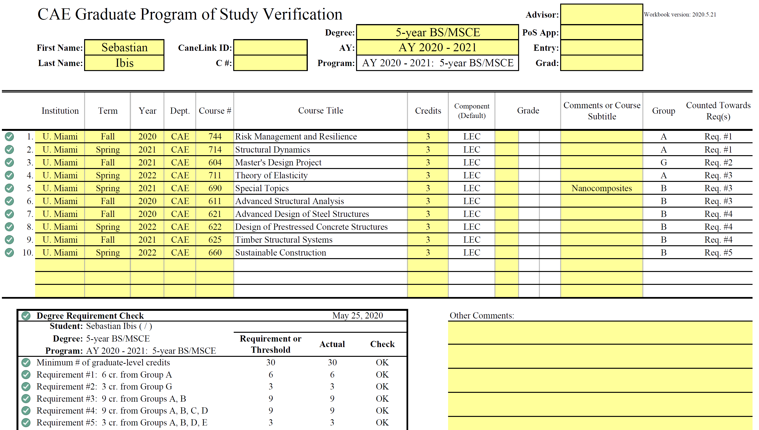

Students must use the Excel tool before obtaining signatures in this Word document. Once the Excel tool verifies that the proposed courses will satisfy the degree requirements, refer to the next section to input the information into the Coursework table in this document.

## Table Format

When completing the Program of Study form, refer to the example below for a summary of the relevant information that is needed for each course. For special courses such as Advanced Topics or Special Topics, specify the subtitle of the course on the Program of Study. For example, specify "Special Topics (Nanocomposites)".

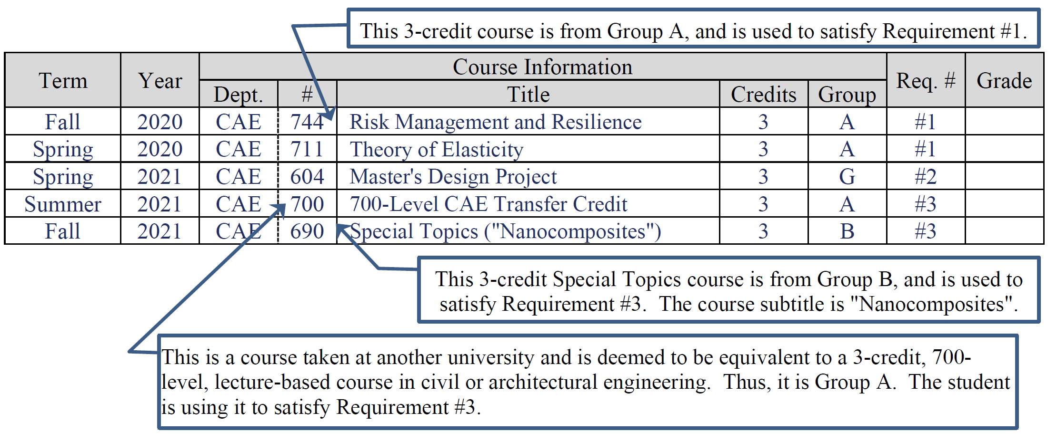

# Helpful Tips ☝

## Student Identification numbers

All students have two unique identification numbers that must be specified on this form:

* University identification number (also known as "UM ID#" or "C Number" or "C#"); 9-digit code beginning with "C"; can be found in [CaneLink](https://canelink.miami.edu) ⭢ *Personal Information* ⭢ *View your UM ID*.
* CaneLink identification number (also known as "emplID" or "CaneLink#" or "CaneLink ID#"); 8-digit code usually beginning with "5"; can be found in [CaneLink](https://canelink.miami.edu) ⭢ *Student Center* ⭢ *Personal Information* ⭢ *Demographic Data*.

# Instructions to Complete This Form

When completing this Program of Study form, type the relevant fields, except where the symbol ✍ denotes digitally-certified initials or signatures.

Upon acceptance into the Graduate Program, you (the student) should follow these steps in order:

1. Read this document and the documents referenced herein in their entirety.
2. Identify a CAE Faculty member that is willing to serve as Supervisory Committee Chair (Advisor). The Advisor must be a full-time faculty member in the CAE Department and a member of the Graduate Faculty; refer to the online [Graduate Faculty List](http://grad.miami.edu/graduate-education/graduate-faculty/index.html).
3. Meet with your Advisor to help: (a) identify other suitable faculty members to constitute a Committee, (b) identify any deficiency courses, and (c) plan out the sequence of courses that will constitute the Program of Study. The Committee requirements are shown on page 1. The coursework requirements are listed on the subsequent pages.
4. Meet with the other prospective Committee members to ask for their willingness to serve on the Committee.
5. Begin formulating a list of courses with your Advisor. Obtain the other Committee members' feedback regarding the proposed set of coursework and whether it constitutes an appropriate basis for the degree sought.
6. Download the Excel checker tool from the [CAE Graduate Program](https://cae.coe.miami.edu/graduate/index.html) website (under Graduate Student Resources). Open the Excel workbook and enter the appropriate information into the yellow shaded cells. The tool should automatically check *most* (not all) graduate course requirements; scroll down in the Excel worksheet to verify.
7. Assuming the course requirements were satisfied in the previous step, complete this Program of Study in Word format. This includes Sections 6, and 7 through 9 (on the page relevant to your degree program). Have your Advisor carefully check it.
8. Email the Word and Excel files to the CAE Graduate Program Director (Dr. Giancaspro [jwgiancaspro@miami.edu](mailto:jwgiancaspro@miami.edu?subject=Program%20of%20Study%20-%20ready%20for%20review)) for review; cc your Advisor on the email.
9. After receiving confirmation from Dr. Giancaspro, print/convert this Word document into a PDF file using Adobe Acrobat. The following pages must be included in the PDF:
10. Page 6 – Program of Study Acknowledgement & Agreement
11. Either page 7, 8, 9, 10, 11, 12, or 13 – your relevant Program of Study
12. Obtain digitally-signed signatures on the PDF form from the individuals listed in Section 9 for your relevant degree program. This can be accomplished in *Adobe Acrobat®* by using the Digitally Sign option:

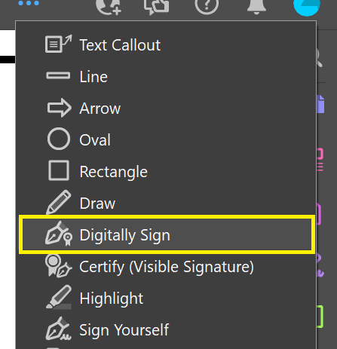

(New Adobe users can find tutorials online by searching for "Adobe Sign a document using a digital signature" in any search engine.)

1. Create a zipped or compressed folder that includes the following: (a) Program of Study in Word format, (b) Excel checker in .xls format, and (c) signed Program of Study in PDF format. Be sure that the names of the files and the folder include your name. Email the folder to the CAE Graduate Program Director (Dr. Giancaspro [jwgiancaspro@miami.edu](mailto:jwgiancaspro@miami.edu?subject=Program%20of%20Study%20-%20ready%20for%20review)). Use this subject line: "Approved Program of Study documents | your name"
2. 1. M.S. students: Obtain an electronic course registration form from your Advisor so that you can obtain your Advisor's electronic signature to enroll for courses.
   2. Ph.D. students: Contact your Advisor and the CAE Graduate Student Handbook for the next steps depending on whether you are applying for admission into Ph.D. candidacy.

# Program of Study Acknowledgement & Agreement

|  |  |  |  |  |  |  |  |  |
| --- | --- | --- | --- | --- | --- | --- | --- | --- |
| I, | **Sebastian Ibis** | (C#: | **C........** | CaneLink#: | **5.......** | | ) | , acknowledge that I have |
| received this Program of Study (PoS) form for my intended degree ( | | | | | | ................. | | ) at the University of |

Miami's College of Engineering. Once fully approved, this form constitutes my graduate course degree requirements.

|  |  |
| --- | --- |
| Initials ↓ | |
| * I have read all documents related to university policies and my degree program, including the relevant sections of the *Academic Bulletin*, *CAE* *Graduate Student Handbook*, *Graduate School Honor Code*, *Graduate School's Student Handbook*, and this *Program of Study* form. | ✍ |
| * I am aware that the Academic Bulletin states: "*It is the responsibility of the student to be informed concerning all regulations and procedures required. In no case will a regulation be waived or an exception granted because a student pleads ignorance of the regulation or asserts that he/she was not informed of it by an advisor or other authority*." | ✍ |
| * I understand the implications of the Graduate Repeat Rule if I fail a class. | ✍ |
| * I understand that I may be terminated from the Graduate Program for unethical behavior, and I accept full responsibility for my actions. I understand that the Graduate School reserves the right (and my registration concedes the right) to require my withdrawal if deemed sufficient by the Graduate School. | ✍ |
| I understand that it is my responsibility to: |  |
| * Consult with the Graduate Program Director to ensure that my graduate application includes official transcripts, diplomas, and evaluations after each degree has been conferred | ✍ |
| * Fulfill the degree and course requirements in the Program of Study and the Bulletin | ✍ |
| * Finish Incomplete courses ("I") within the time limit specified by the instructor, or 1 calendar year (whichever comes first) | ✍ |
| * Enroll in only those courses approved in my Program of Study | ✍ |
| * Provide regular progress updates to my Supervisory Committee at least once per semester | ✍ |
| * Achieve a cumulative GPA of "B" or better, and no grade below "C" in all graduate courses | ✍ |
| * Submit a new Program of Study if I want to revise my coursework |  |
| * Submit a new graduate application if I want to change my intended degree program | ✍ |
| * Ph.D.: Register for at least 1 credit of CAE 840 or 850 in the semester in which I defend my dissertation, and again in the semester in which I graduate | ✍ |
| * Ph.D.: Complete and submit the forms for *Admission to Candidacy* immediately after passing the Qualifying Exam with the Dissertation Proposal | ✍ |
| * M.S. (thesis option): Register for at least 1 credit of CAE 810 or 820 in the semester in which I defend my dissertation, and again in the semester in which I graduate | ✍ |
| * Ph.D. and M.S. (thesis option): Notify the Graduate School and the CAE Graduate Secretary of my dissertation/thesis defense at least 10 days prior to the event | ✍ |
| * Ph.D. and M.S. (thesis option): Successfully defend the dissertation or thesis by oral examination, and complete any additional requirements stipulated by the Supervisory Committee | ✍ |

My dated signature below affirms that I have read and understood this entire -page form and the documents referenced herein, and I agree to comply with all requirements.

|  |  |  |
| --- | --- | --- |
| ✍ |  |  |
| Signature (handwritten or digitally signed) |  | Date |

Program of Study: 5-Year B.S.-M.S.

# Student Information

|  |  |  |  |
| --- | --- | --- | --- |
| Full Name: | **Sebastian Ibis** | | |
| C# and CaneLink ID #: | **C........** | | **5.......** |
| Degree Sought and Major Area of Study: | Degree | Major Area of Study | Thesis Option |
| ................. | ................. | Non-Thesis |

# Coursework

|  |  |  |  |  |  |  |  |  |  |  |
| --- | --- | --- | --- | --- | --- | --- | --- | --- | --- | --- |
|  | | Term | Year | Course Information | | | | | Req. # | Grade |
| Dept. | # | Title | Credits | Group |
| Deficiencies (if any) | 1. |  |  |  |  |  |  |  |  |  |
| 2. |  |  |  |  |  |  |  |  |  |
| 3. |  |  |  |  |  |  |  |  |  |

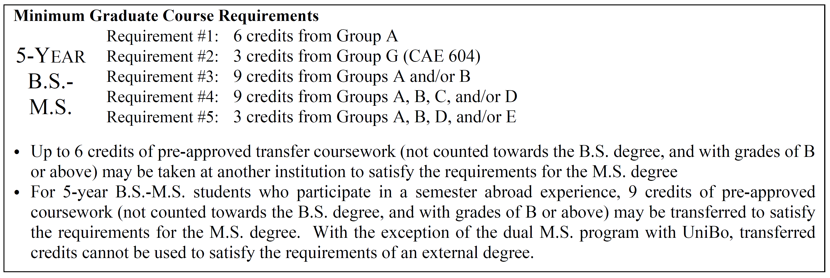

|  |  |  |  |  |  |  |  |  |  |  |
| --- | --- | --- | --- | --- | --- | --- | --- | --- | --- | --- |
|  | | Term | Year | Course Information | | | | | Req. # | Grade |
| Dept. | # | Title | Credits | Group |
| Required (Proposed) | 1. |  |  | CAE | 7xx |  | 3 | A | #1 |  |
| 2. |  |  | CAE | 7xx |  | 3 | A | #1 |  |
| 3. | Spring |  | CAE | 604 | Master's Design Project | 3 | G | #2 |  |
| 4. |  |  |  |  |  |  |  |  |  |
| 5. |  |  |  |  |  |  |  |  |  |
| 6. |  |  |  |  |  |  |  |  |  |
| 7. |  |  |  |  |  |  |  |  |  |
| 8. |  |  |  |  |  |  |  |  |  |
| 9. |  |  |  |  |  |  |  |  |  |
| 10. |  |  |  |  |  |  |  |  |  |
| 11. |  |  |  |  |  |  |  |  |  |

# Signatures and Approvals of Supervisory Committee

|  |  |  |  |  |  |
| --- | --- | --- | --- | --- | --- |
|  | Title | Name | Affiliation | Signature | Date |
|  | CAE Student |  | CAE | ✍ | ✍ |
| 1. | CAE Committee Chair (Advisor) |  | CAE | ✍ | ✍ |
| 2. | CAE Committee Member |  | CAE | ✍ | ✍ |
| 3. | External Committee Member |  |  | ✍ | ✍ |
| 4. | Additional Member (optional) |  |  |  |  |
| CAE Graduate Program Director | | Dr. Rhode-Barbarigos | CAE | ✍ | ✍ |

Program of Study: M.S.A.E. or M.S.C.E. (Thesis Option)

# Student Information

|  |  |  |  |
| --- | --- | --- | --- |
| Full Name: | **Sebastian Ibis** | | |
| C# and CaneLink ID #: | **C.......** | | **5.......** |
| Degree Sought and Major Area of Study: | Degree | Major Area of Study | Thesis Option |
| ................. | ................. | Thesis (Dissertation) |

# Coursework

|  |  |  |  |  |  |  |  |  |  |  |
| --- | --- | --- | --- | --- | --- | --- | --- | --- | --- | --- |
|  | | Term | Year | Course Information | | | | | Req. # | Grade |
| Dept. | # | Title | Credits | Group |
| Deficiencies (if any) | 1. |  |  |  |  |  |  |  |  |  |
| 2. |  |  |  |  |  |  |  |  |  |
| 3. |  |  |  |  |  |  |  |  |  |

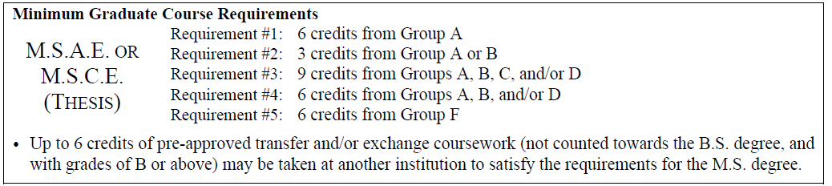

|  |  |  |  |  |  |  |  |  |  |  |
| --- | --- | --- | --- | --- | --- | --- | --- | --- | --- | --- |
|  | | Term | Year | Course Information | | | | | Req. # | Grade |
| Dept. | # | Title | Credits | Group |
| Required (Proposed) | 1. |  |  | CAE | 810 | Master's Thesis | 3 | F | #5 |  |
| 2. |  |  | CAE | 810 | Master's Thesis | 3 | F | #5 |  |
| 3. |  |  | CAE | 7.. |  | 3 | A | #1 |  |
| 4. |  |  | CAE | 7.. |  | 3 | A | #1 |  |
| 5. |  |  |  |  |  |  |  |  |  |
| 6. |  |  |  |  |  |  |  |  |  |
| 7. |  |  |  |  |  |  |  |  |  |
| 8. |  |  |  |  |  |  |  |  |  |
| 9. |  |  |  |  |  |  |  |  |  |
| 10. |  |  |  |  |  |  |  |  |  |
| 11. |  |  |  |  |  |  |  |  |  |
| 12. |  |  |  |  |  |  |  |  |  |

# Signatures and Approvals of Supervisory Committee

|  |  |  |  |  |  |
| --- | --- | --- | --- | --- | --- |
|  | Title | Name | Affiliation | Signature | Date |
|  | CAE Student |  | CAE | ✍ | ✍ |
| 1. | CAE Committee Chair (Advisor) |  | CAE | ✍ | ✍ |
| 2. | CAE Committee Member |  | CAE | ✍ | ✍ |
| 3. | External Committee Member |  |  | ✍ | ✍ |
| 4. | Additional Member (optional) |  |  |  |  |
| 5. | Additional Member (optional) |  |  |  |  |
| CAE Graduate Program Director | | Dr. Rhode-Barbarigos | CAE | ✍ | ✍ |
| Department Chair | | Dr. Shi | CAE | ✍ | ✍ |

Program of Study: M.S.A.E. or M.S.C.E. (Non-Thesis Option)

# Student Information

|  |  |  |  |
| --- | --- | --- | --- |
| Full Name: | **Sebastian Ibis** | | |
| C# and CaneLink ID #: | **C.......** | | **5.......** |
| Degree Sought and Major Area of Study: | Degree | Major Area of Study | Thesis Option |
| ................. | ................. | Non-Thesis |

# Coursework

|  |  |  |  |  |  |  |  |  |  |  |
| --- | --- | --- | --- | --- | --- | --- | --- | --- | --- | --- |
|  | | Term | Year | Course Information | | | | | Req. # | Grade |
| Dept. | # | Title | Credits | Group |
| Deficiencies (if any) | 1. |  |  |  |  |  |  |  |  |  |
| 2. |  |  |  |  |  |  |  |  |  |
| 3. |  |  |  |  |  |  |  |  |  |

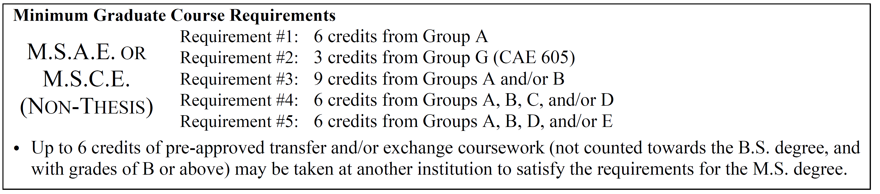

|  |  |  |  |  |  |  |  |  |  |  |
| --- | --- | --- | --- | --- | --- | --- | --- | --- | --- | --- |
|  | | Term | Year | Course Information | | | | | Req. # | Grade |
| Dept. | # | Title | Credits | Group |
| Required (Proposed) | 1. |  |  | CAE | 7.. |  | 3 | A | #1 |  |
| 2. |  |  | CAE | 7.. |  | 3 | A | #1 |  |
| 3. |  |  | CAE | 605 | Master's Project | 3 | G | #2 |  |
| 4. |  |  |  |  |  |  |  |  |  |
| 5. |  |  |  |  |  |  |  |  |  |
| 6. |  |  |  |  |  |  |  |  |  |
| 7. |  |  |  |  |  |  |  |  |  |
| 8. |  |  |  |  |  |  |  |  |  |
| 9. |  |  |  |  |  |  |  |  |  |
| 10. |  |  |  |  |  |  |  |  |  |
| 11. |  |  |  |  |  |  |  |  |  |
| 12. |  |  |  |  |  |  |  |  |  |

# Signatures and Approvals of Supervisory Committee

|  |  |  |  |  |  |
| --- | --- | --- | --- | --- | --- |
|  | Title | Name | Affiliation | Signature | Date |
|  | CAE Student |  | CAE | ✍ | ✍ |
| 1. | CAE Committee Chair (Advisor) |  | CAE | ✍ | ✍ |
| 2. | CAE Committee Member |  | CAE | ✍ | ✍ |
| 3. | External Committee Member |  |  | ✍ | ✍ |
| 4. | Additional Member (optional) |  |  |  |  |
| 5. | Additional Member (optional) |  |  |  |  |
| CAE Graduate Program Director | | Dr. Rhode-Barbarigos | CAE | ✍ | ✍ |
|  | |  |  |  |  |

Program of Study: Dual M.S.C.E. with UniBo (UM Students)

# Student Information

|  |  |  |  |
| --- | --- | --- | --- |
| Full Name: | **Sebastian Ibis** | | |
| C# and CaneLink ID #: | **C.......** | | **5.......** |
| Degree Sought and Major Area of Study: | Degree | Major Area of Study | Thesis Option |
| ................. | ................. | Thesis |

# Coursework

|  |  |  |  |  |  |  |  |  |  |
| --- | --- | --- | --- | --- | --- | --- | --- | --- | --- |
|  | | Term | Year | Course Information | | | | | Grade |
| Dept. | # | Title | Credits | Table |
| Deficiencies (if any) | 1. |  |  |  |  |  |  |  |  |
| 2. |  |  |  |  |  |  |  |  |
| 3. |  |  |  |  |  |  |  |  |

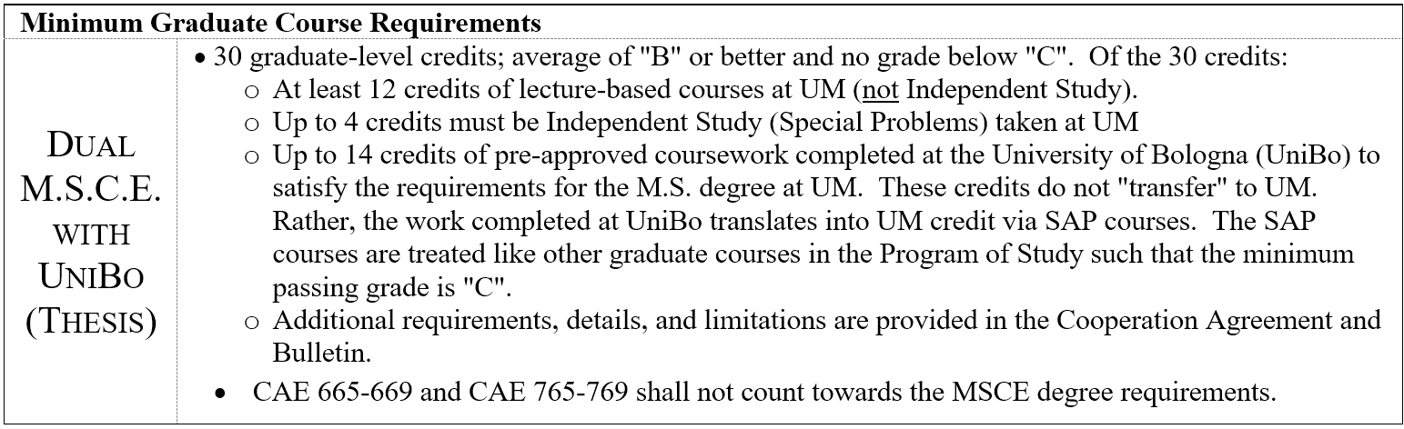

|  |  |  |  |  |  |  |  |  |  |  |  |  |
| --- | --- | --- | --- | --- | --- | --- | --- | --- | --- | --- | --- | --- |
|  | | Register for the following UM Graduate courses during Senior Year | | | | | | | | | | |
| Required (Proposed) | 1. | Fall |  | CAE |  |  | | | 3 |  |  |  |
| 2. | Fall |  | CAE |  |  | | | 3 |  |  |  |
| 3. | Spring |  | CAE | 604 | Master's Design Project | | | 3 |  |  |  |
| 4. | Spring |  | CAE |  |  | | | 3 |  |  |  |
| Register for the following UM Graduate courses while studying abroad at UniBo | | | | | | | | | | | |
|  | Term | Year | UM Course Registration | | UniBo Course # and Title | U.S. Credits | UM Course Equivalent | | | | Grade |
| 5. | Fall |  | CAE | 795 | Civil Eng. Research | 2 | Special Problems; section "SAP" | | | |  |
| 6. | Fall |  | SAP (G01) | G01 |  | 3 |  | | | |  |
| 7. | Fall |  | SAP (G02) | G02 |  | 2 |  | | | |  |
| 8. | Fall |  | SAP (G03) | G03 |  | 2 |  | | | |  |
| 9. | Spring |  | CAE | 795 | Civil Eng. Research | 2 | Special Problems; section "SAP" | | | |  |
| 10. | Spring |  | SAP (G01) | G01 |  | 3 |  | | | |  |
| 11. | Spring |  | SAP (G02) | G02 |  | 2 |  | | | |  |
| 12. | Spring |  | SAP (G03) | G03 |  | 2 |  | | | |  |

# Signatures and Approvals of Supervisory Committee

|  |  |  |  |  |  |
| --- | --- | --- | --- | --- | --- |
|  | Title | Name | Affiliation | Signature | Date |
|  | CAE Student |  | CAE | ✍ | ✍ |
| 1. | CAE Committee Chair (Advisor) |  | CAE | ✍ | ✍ |
| 2. | CAE Committee Member |  | CAE | ✍ | ✍ |
| 3. | External Committee Member |  |  | ✍ | ✍ |
| 4. | Additional Member (optional) |  |  |  |  |
| CAE Graduate Program Director | | Dr. Rhode-Barbarigos | CAE | ✍ | ✍ |
| Department Chair | | Dr. Shi | CAE | ✍ | ✍ |

Program of Study: Dual M.S.C.E. with UM (UniBo Students)

# Student Information

|  |  |  |  |
| --- | --- | --- | --- |
| Full Name: | **Sebastian Ibis** | | |
| C# and CaneLink ID #: | **C.......** | | **5.......** |
| Degree Sought and Major Area of Study: | Degree | Major Area of Study | Thesis Option |
| MSCE | ................. | Thesis |

# Coursework

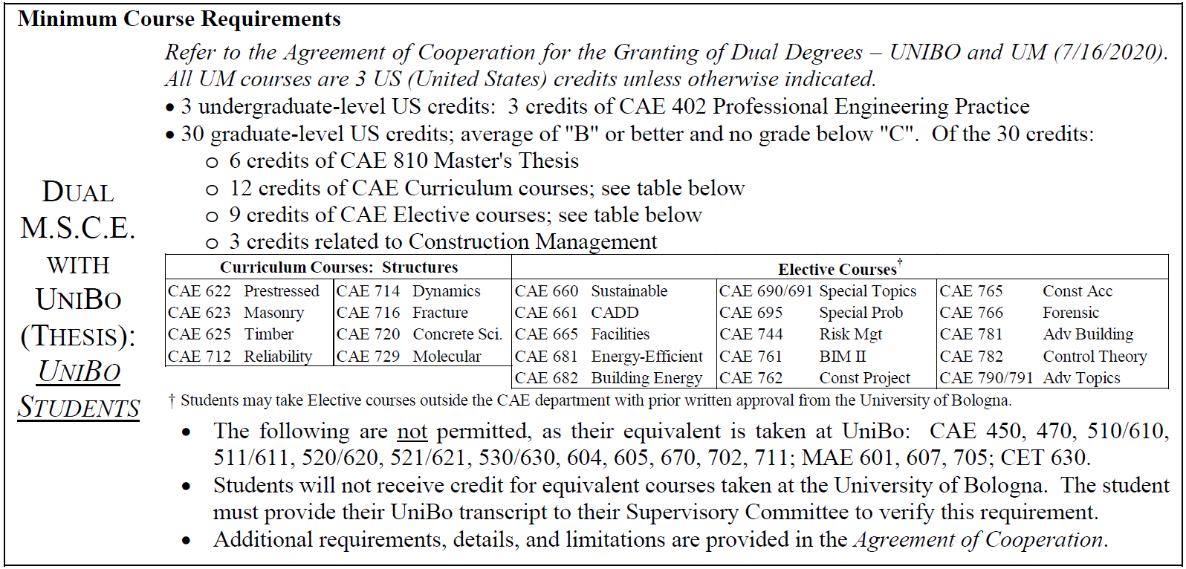

|  |  |  |  |  |  |  |  |  |  |
| --- | --- | --- | --- | --- | --- | --- | --- | --- | --- |
|  | | Term | Year | Undergraduate Course Information | | | | | Grade |
| Dept. | # | Title | Credits |  |
| Required (Proposed) | 1. |  |  | CAE | 402 | Professional Engineering Practice | 3 |  |  |
|  | Graduate Course Information | | | | | | | |
| 1. | Fall |  | CAE | 810 | Master's Thesis |  |  |  |
| 2. | Fall |  |  |  |  |  |  |  |
| 3. | Fall |  |  |  |  |  |  |  |
| 4. | Fall |  |  |  |  |  |  |  |
| 5. | Fall |  |  |  |  |  |  |  |
| 6. | Spring |  | CAE | 810 | Master's Thesis |  |  |  |
| 7. | Spring |  |  |  |  |  |  |  |
| 8. | Spring |  |  |  |  |  |  |  |
| 9. | Spring |  |  |  |  |  |  |  |
| 10. | Spring |  |  |  |  |  |  |  |
| 11. | Summer |  | CAE | 810 | Master's Thesis |  |  |  |

# Signatures and Approvals of Supervisory Committee

|  |  |  |  |  |  |
| --- | --- | --- | --- | --- | --- |
|  | Title | Name | Affiliation | Signature | Date |
|  | CAE Student |  | CAE | ✍ | ✍ |
| 1. | CAE Committee Chair (UM Advisor) |  | CAE | ✍ | ✍ |
| 2. | CAE Member |  | CAE | ✍ | ✍ |
| 3. | External Member (UniBo Advisor) |  | UniBo | ✍ | ✍ |
| UM CAE Graduate Program Director | | Dr. Rhode-Barbarigos | CAE | ✍ | ✍ |
| UM CAE Department Chair | | Dr. Shi | CAE | ✍ | ✍ |

Program of Study: Ph.D. (with prior M.S.)

# Student Information

|  |  |  |  |
| --- | --- | --- | --- |
| Full Name: | **Sebastian Ibis** | | |
| C# and CaneLink ID #: | **C.......** | **5.......** | |
| Degree Sought and Major Area of Study: | Degree | Major Area of Study |  |
| Ph.D. in Civil Engineering | ................. |  |

# Coursework

|  |  |  |  |  |  |  |  |  |  |  |
| --- | --- | --- | --- | --- | --- | --- | --- | --- | --- | --- |
|  | | Term | Year | Course Information | | | | | Req. # | Grade |
| Dept. | # | Title | Credits | Group |
| Deficiencies (if any) | 1. |  |  |  |  |  |  |  |  |  |
| 2. |  |  |  |  |  |  |  |  |  |
| 3. |  |  |  |  |  |  |  |  |  |

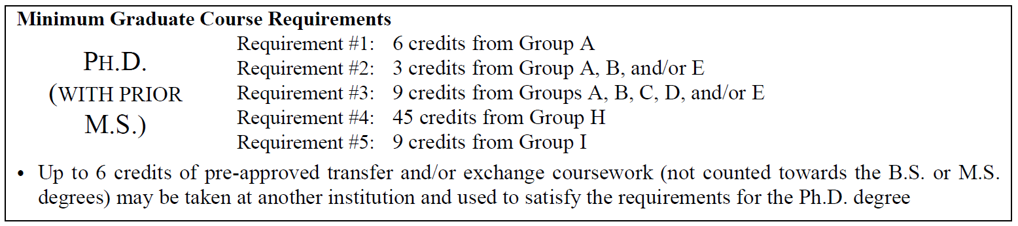

|  |  |  |  |  |  |  |  |  |  |  |
| --- | --- | --- | --- | --- | --- | --- | --- | --- | --- | --- |
|  | | Term | Year | Course Information | | | | | Req. # | Grade |
| Dept. | # | Title | Credits | Group |
| Required (Proposed) | 1. |  |  | CAE | 7.. |  | 3 | A | #1 |  |
| 2. |  |  |  |  |  |  |  |  |  |
| 3. |  |  |  |  |  |  |  |  |  |
| 4. |  |  |  |  |  |  |  |  |  |
| 5. |  |  |  |  |  |  |  |  |  |
| 6. |  |  |  |  |  |  |  |  |  |
| 7. |  |  |  |  |  |  |  |  |  |
| 8. |  |  |  |  |  |  |  |  |  |
| 9. |  |  |  |  |  |  |  |  |  |
| 10. |  |  |  |  |  |  |  |  |  |
| 11. |  |  |  |  |  |  |  |  |  |
| 12. |  |  |  |  |  |  |  |  |  |
| 13. |  |  |  |  |  |  |  |  |  |
| 14 |  |  |  |  |  |  |  |  |  |
| 15. |  |  |  |  |  |  |  |  |  |

# Signatures and Approvals of Supervisory Committee

|  |  |  |  |  |  |
| --- | --- | --- | --- | --- | --- |
|  | Title | Name | Affiliation | Signature | Date |
|  | CAE Student |  | CAE | ✍ | ✍ |
| 1. | CAE Committee Chair (Advisor) |  | CAE | ✍ | ✍ |
| 2. | CAE Committee Member |  | CAE | ✍ | ✍ |
| 3. | CAE Committee Member |  | CAE | ✍ | ✍ |
| 4. | External Committee Member |  |  | ✍ | ✍ |
| 5. | Additional Member (optional) |  |  |  |  |
| CAE Graduate Program Director | | Dr. Rhode-Barbarigos | CAE | ✍ | ✍ |
| Department Chair | | Dr. Shi | CAE | ✍ | ✍ |

Program of Study: Ph.D. (without prior M.S.)

# Student Information

|  |  |  |  |
| --- | --- | --- | --- |
| Full Name: | **Sebastian Ibis** | | |
| C# and CaneLink ID #: | **C.......** | **5.......** | |
| Degree Sought and Major Area of Study: | Degree | Major Area of Study |  |
| Ph.D. in Civil Engineering | ................. |  |

# Coursework

|  |  |  |  |  |  |  |  |  |  |  |
| --- | --- | --- | --- | --- | --- | --- | --- | --- | --- | --- |
|  | | Term | Year | Course Information | | | | | Req. # | Grade |
| Dept. | # | Title | Credits | Group |
| Deficiencies (if any) | 1. |  |  |  |  |  |  |  |  |  |
| 2. |  |  |  |  |  |  |  |  |  |
| 3. |  |  |  |  |  |  |  |  |  |

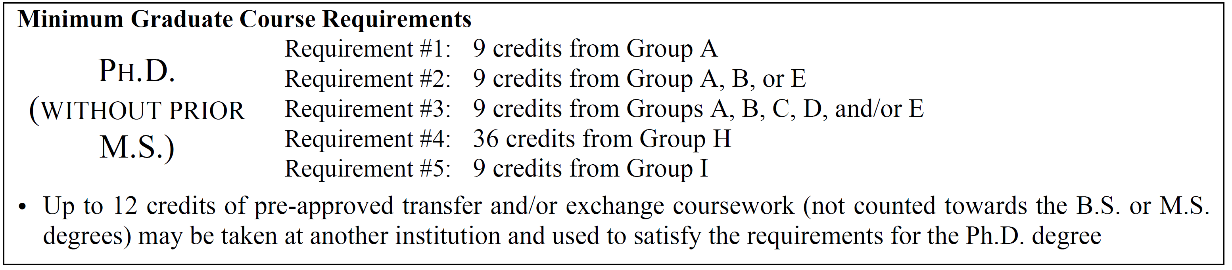

|  |  |  |  |  |  |  |  |  |  |  |
| --- | --- | --- | --- | --- | --- | --- | --- | --- | --- | --- |
|  | | Term | Year | Course Information | | | | | Req. # | Grade |
| Dept. | # | Title | Credits | Group |
| Required (Proposed) | 1. |  |  | CAE | 7.. |  | 3 | A | #1 |  |
| 2. |  |  |  |  |  |  |  |  |  |
| 3. |  |  |  |  |  |  |  |  |  |
| 4. |  |  |  |  |  |  |  |  |  |
| 5. |  |  |  |  |  |  |  |  |  |
| 6. |  |  |  |  |  |  |  |  |  |
| 7. |  |  |  |  |  |  |  |  |  |
| 8. |  |  |  |  |  |  |  |  |  |
| 9. |  |  |  |  |  |  |  |  |  |
| 10. |  |  |  |  |  |  |  |  |  |
| 11. |  |  |  |  |  |  |  |  |  |
| 12. |  |  |  |  |  |  |  |  |  |
| 13. |  |  |  |  |  |  |  |  |  |
| 14. |  |  |  |  |  |  |  |  |  |
| 15. |  |  |  |  |  |  |  |  |  |
| 16. |  |  |  |  |  |  |  |  |  |
| 17. |  |  |  |  |  |  |  |  |  |
| 18. |  |  |  |  |  |  |  |  |  |
| 19. |  |  |  |  |  |  |  |  |  |
| 20. |  |  |  |  |  |  |  |  |  |
| 21. |  |  |  |  |  |  |  |  |  |
| 22. |  |  |  |  |  |  |  |  |  |
| 23. |  |  |  |  |  |  |  |  |  |
| 24. |  |  |  |  |  |  |  |  |  |
| 25. |  |  |  |  |  |  |  |  |  |
|  |  |  |  |  |  |  |  |  |  |
|  |  |  |  |  |  |  |  |  |  |

# Signatures and Approvals of Supervisory Committee

|  |  |  |  |  |  |
| --- | --- | --- | --- | --- | --- |
|  | Title | Name | Affiliation | Signature | Date |
|  | CAE Student |  | CAE | ✍ | ✍ |
| 1. | CAE Committee Chair (Advisor) |  | CAE | ✍ | ✍ |
| 2. | CAE Committee Member |  | CAE | ✍ | ✍ |
| 3. | CAE Committee Member |  | CAE | ✍ | ✍ |
| 4. | External Committee Member |  |  | ✍ | ✍ |
| 5. | Additional Member (optional) |  |  |  |  |
| 6. | Additional Member (optional) |  |  |  |  |
| 7. | Additional Member (optional) |  |  |  |  |
| CAE Graduate Program Director | | Dr. Rhode-Barbarigos | CAE | ✍ | ✍ |
| Department Chair | | Dr. Shi | CAE | ✍ | ✍ |

🗏 This page should be printed on 8.5" × 14" Legal size paper.